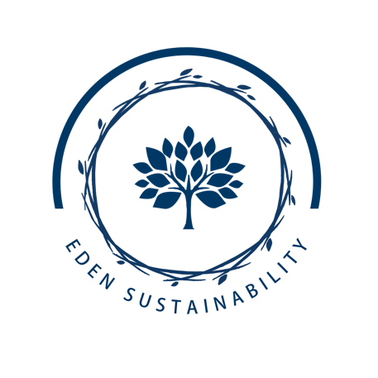

Eden Sustainability Service Teams

Purpose: To create organized groups of dedicated school students and leaders who are committed to drive action and contribute to Landmark Christian Schools’ sustainable campus culture.

Objectives: (Students and leaders will be able to do)
- Implement sustainability initiatives.
- Educate and engage community on ecological issues.
- Share innovative ideas.

Sponsored Organizations:
- National Green Schools Society- Project Green Schools
https://projectgreenschools.org/national-green-schools-society-ngss/#:~:text=National%20Green%20Schools%20Society%20provides,a%20state%20and%20national%20level
- National Wildlife Federation Eco Schools US
https://www.nwf.org/eco-schools-us

Service Teams:

Elementary: Eden Eco-Eagles (5th grade student weekly leaders)
- Empty Grades 1-5th Classroom Blue Paper Recycle Bins weekly.
- Encourage proper stacking of Styrofoam in lunchroom.
- Garden Entrepreneurs

Middle School: Eden Green Team
- Coordinate with Houses to organize “green” competitions.
- Promote monthly green calendar initiatives. (https://projectgreenschools.org/annual-conservation-and-environmental-days-to-celebrate/ )
- Encourage proper stacking of Styrofoam in lunchroom.
- Work the Grove Park and Grove Park Learning Gardens and Grove Park Pollinator Habitat

High School: Eden NGSS Stewards
- Initiates projects with HS Advisories
- Organizes community events by serving on one of our 5 main teams.
  - Pollinator Partners
    - Oversees HS Pollinator Project initiatives.
    - Plants new seasonal pollinator plants.
    - Maintains HS Pollinator Project area.
  - 3R Team
    - Coordinates Paper Recycling Classroom Blue Bin activities.
    - Runs the Used Clothing Collections and Sales.
    - Plans new reducing, reusing, recycling programs (straws, plastic bottles etc.)
    - Fills Styro-Genie weekly.
  - Culinary Arts
    - Promotes Farm to Table stands.
    - Produces monthly news blurb about nutrition from gardens.
    - Decides student recipes for tastings.
  - Project Wild
    - Organizes monthly WWF monthly animal awareness days.
    - Educates LCS community of students about animals.
    - Maintains Chicken-coop, Classroom habitats.
  - Ground Breakers
    - Oversees Smile Sheds Project.
    - Maintains HS Victory Garden.
    - Seeds new plants and waters indoor grow light stations.
    - Coordinates with Adult Ed Garden classes.

