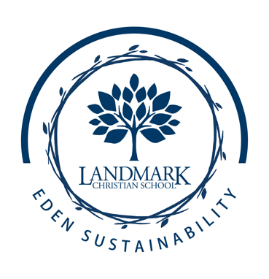

**Eden Sustainability Projects**

**Purpose:** To support, service, and sustain Eden Sustainability and Agricultural Sciences programs at Landmark Christian School.

**Objectives:**

* Provide learning opportunities about environmental issues that matter to our students and community.
* Collaborate with state and national organizations to learn protective and preventive measures of sustainability.
* Construct projects that assist with maintenance of sustainable initiatives.

**Elementary (Grades 1-5)**

**4LIFE Class Extension Projects**

1st- Worms, Pill Bugs, Soil, Forests (Soil Science Society of America, U.S. Forest Service)

2nd- Butterflies, Birds, and Bats (Monarchs Across America, Nature Conservancy, T.E.R.N., Wild Birds Unlimited, Cornell Lab of Ornithology)

3rd- Plants and Pollinators (Bonnie Cabbage Program and Bee Smart)

4th- Chicks in the Classroom (National Agriculture in the Classroom)

5th- Garden Eco-Entrepreneurs (Primary Awards for Green Education in Schools, Project Green Schools, Eco-Schools)

**Middle School (Grades 6-8)**

NGSS Project Green Schools Certification Programs

Zero Waste Initiatives:

- Styro-Genie

- Houses Green Competitions

- Project H20

- Blue Bin Bundles BBB Project (Paper recycling)

Conservation Initiatives:

* Project Wild Club
* Garden Serve Days
* Grove Learning Gardens and Grove Pollinator Habitat

**High School (Grades 9-12)**

NGSS Project Green Schools Certification Programs

STEWARDS (Pollinator Partners, 3R Team, Groundbreakers, Project Wild, Culinary Arts)

National Wildlife Federation Eco- Schools Certification Projects  
 Environmental Science Principles Course Labs

Student Supported Projects

LPA Pollinator Project- Community Pollinator Packs

Smile Sheds- Community Garden Outreach Program

School Victory Garden

Pollinator Project Habitat

Orchard Hall of Honors