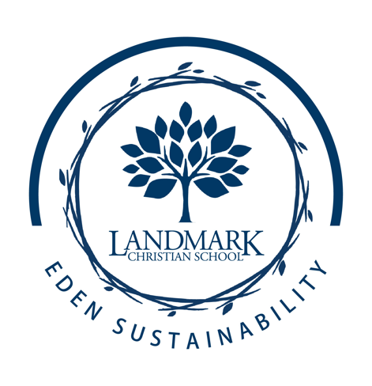
LANDMARK STUDENTS
TAKE LEARNING OUTSIDE K12
4LIFE Nature School
Classes-Connections-Community

Purpose:
Multiple studies have shown that it is essential to incorporate the outdoor natural environment into the psychological and educational development of children. Outdoor learning increases student engagement in school, defuses stress and anxiety, and fosters motivated and self-directed growth. Student engagement in school increases even after lessons are held outdoors. Ultimately, adventure outdoor education challenges the student to be an experiential learner, participant-centered leader, and a steward of the environment. Ultimately, 4LIFE Nature School’s purpose is to increase student environmental literacy through applied outdoor scientific discovery.

Objectives:
- Foster awareness and knowledge about the environment and related issues.
- Develop critical thinking and processing skills.
- Foster positive attitudes, motivations, and commitments to make informed decisions.
- Take responsible actions towards presented situations.
- Learn “How” to think; not “what” to think (applied science).

Program:
Our Outdoor Nature School is called 4LIFE. This is a 4-part program under Landmark's EDEN Sustainability initiative provides opportunities for students to be engaged in activities outdoors. Nature is the classroom at 4LIFE Nature School. Respect, collaboration, exploration, and discovery are centered disciplines that are incorporated into the experiences.

4LIFE Stands For:
1- Life: Purposing Community (Team Building)
2- Life: Pondering Natural Wonders (Processes that cause life to function)
3- Life: Practicing Environmental Sustainability (Protecting/Preparing future resources)
4- Life: Planting Gardens with purpose (Reaping the rewards of work)

Program Structure :
Classes: Grades K4-5th
Connections: Grades 6th-8th
Community: Grades 9th-12th

4LIFE Classes by Grade Targeted Outdoor Education Extensions:
1st- Worms, Pill Bugs, Soil, Forests (Soil Science Society of America, U.S. Forest Service)
2nd- Butterflies, Birds, and Bats (Monarchs Across America, Nature Conservancy, T.E.R.N., Wild Birds Unlimited, Cornell Lab of Ornithology)
3rd- Plants and Pollinators (Bonnie Cabbage Program and Bee Smart)
4th- Chicks in the Classroom (National Agriculture in the Classroom)
5th- Garden Eco-Entrepreneurs (Primary Awards for Green Education in Schools, Project Green Schools, Eco-Schools)

